THE UNIVERSITY OF DODOMA

COLLEGE OF INFORMATICS AND VIRTUAL EDUCATION
DEPARTMENT OF COMPUTER SCIENCE AND ENGINEERING

FINAL YEAR PROJECT REPORT

BSc Computer Networks and Information Security Engineering (CNISE)
PROJECT TITLE:

PROJECT TITLE: SECURING BIOMETRIC DATA TRANSACTIONS FROM SENSOR TO ENGINE

STUDENT’S PARTICULARS: GROUP 10
S/N | REGISTRATION NUMBER | STUDENT’S NAMES
 | T21-03-02345 | ANGELINA A. KILINDO
 | T21-03-15705 | BARAKATI ABDI HUSSEIN
 | T21-03-03127 | ESTOMINIH EPHREM SANAYA
 | T/UDOM/2020/05258 | ELISHA M MAHENDA

SUPERVISOR NAME: MS NEEMA
Signature: ...............................

SEMISTER TWO
TABLE OF CONTENTS

LIST OF TABLES ii
LIST OF FIGURES iii
CHAPTER 1: INTRODUCTION 1
1.1. Background 1
1.2. Problem Statement 1
1.3. Solution 1
1.4. Main Objective 1
1.5. Specific Objectives 1
1.6. Scope 2
CHAPTER 2: LITERATURE REVIEW 3
2.1 Related work 4
2.2 Supporting Document in this Study 4
2.2.1 Traditional Authentication Methods 4
2.2.2 Biometrics Authentication for Zero Trust Access Control 4
CHAPTER 3: METHODOLOGY 6
3.1 Introduction 6
3.2 Approach 7
3.4.1 Architecture Diagram 7
3.5 Software and Hardware Requirements 8
3.5.1 Software 8
3.5.2 Hardware 8
3.6 Data Collection and Storage 8
3.6.1 Biometric Data Collection 9
3.7 Implementation Steps 9
CHAPTER 4: IMPLEMENTATION PHASE 10
4.1. Current Progress 10
CHAPTER 5: MARKET STRATEGY 16
5.1. Potential Customers 16
5.2. Competitors 16
4.3 Revenue Stream 17
CHAPTER 6: PROJECT TIMELINE AND BUDGET 18
6.1. Project Timeline 18
6.2. Project Budget 20
CHAPTER 7: CONCLUSION 21
7.1. Summary 21
REFERENCES 22

LIST OF TABLES

Table 1 : Project Timeline 17
Table 2 : The Project Budget 18

LIST OF FIGURES

Figure 1: Agaile Aproach 7
Figure 2: System Design Architecture 8
Figure 3: Database Setup 11
Figure 4: User Enrolment code 11
Figure 5: Backend 12
Figure 6: Authentication 12
Figure 7: Api for communication between frontend and backend 13
Figure 8: Backend Logic 13
Figure 9: Frontend logic for protecting reply attack 14
Figure 10: Frontend nonce creation 14
Figure 11: Urer Enrolment 15
Figure 12: User Authentication 15

CHAPTER 1: INTRODUCTION

Background
Many systems today rely on sensors to collect data and send it to processing engines for decision-making. However, the data sent from sensors to engines can be attacked, changed, or intercepted by hackers. Traditional security methods, like passwords or simple encryption, are not always strong enough to protect these transactions. This project focuses on making sure that every transaction between a sensor and an engine is secure, preventing unauthorized access and data tampering.

Problem Statement
Sensor-based systems are used in industries like IoT, smart cities, and automation. However, they face serious security risks. Hackers can intercept or modify transactions, leading to wrong decisions, financial loss, or security breaches. Many existing security solutions do not fully protect transactions, making it easy for attackers to exploit weak points. A better way is needed to secure transactions, making sure they are safe, authentic, and cannot be changed by unauthorized users.

Solution
This project aims to secure transactions between sensors and processing engines by using strong security measures. These include encryption to protect data, authentication to verify users, and integrity checks to prevent data changes. By applying these security techniques, the system will ensure that transactions remain safe and reliable.

Main Objective
To protect transactions from sensors to engines using strong security techniques such as authentication, encryption, and integrity checks.

Specific Objectives
- To identify the security risks in sensor-to-engine transactions and find the best ways to protect them.
- To design a security system that includes authentication, encryption, and integrity checks.
- To develop and test the system to ensure it works effectively.
- To evaluate the system’s ability to stop unauthorized access and data tampering.

Scope
This project focuses on making transactions between sensors and engines secure by using advanced security techniques. The main areas covered in the project include:
Transaction Authentication
- Ensure that every transaction comes from a trusted source before being processed.
- Apply strict access control to prevent unauthorized actions.
Data Encryption and Integrity Protection
- Use encryption to keep data safe while it is being sent.
- Apply integrity checks to make sure the data has not been changed.
Zero-Trust Access Control
- Verify each transaction before allowing it to be processed.
- Continuously check for security threats and stop unauthorized activity.
System Testing and Improvement
- Test the system to find weaknesses and improve security.
- Update security measures regularly to stay ahead of new threats.

CHAPTER 2: LITERATURE REVIEW

User authentication is a critical aspect of securing web platforms and digital services. Existing research highlights the limitations of traditional authentication methods and explores the potential of integrating advanced technologies such as biometrics to enhance security. A. K. Jain, et al, (2002). The literature describes the potential of integrating biometrics and to overcome the limitations of traditional authentication methods.
Biometric systems offer a more secure and user-friendly alternative to traditional methods. According to N.K. Ratha et al. (2001), various biometric technologies, such as fingerprints, facial recognition, and iris scans, provide unique and non-transferable credentials. However, these systems are not without vulnerabilities. Arwa Al-Hussain et al. (2010) highlighted the importance of implementing liveness detection techniques to mitigate risks and ensure authenticity during enrollment and verification, although the proposed solutions were not fully implemented.
Based on our analysis of the current liveness detection landscape, and having identified its inherent technical and operational weaknesses, we have developed a new model of trait vitality checks that is capable of enhancing the effective security of the biometric authentication strategy while remaining non-intrusive and user-friendly. Untapped areas exist in Mult-Biometrics and Liveness Detection, including the need to focus research on developing a comprehensive taxonomy of Liveness Detection necessary to advance further knowledge in the field of biometric security. (Kenneth Okereafor, et al, 2016).
Security attack proof protection scheme. Although some potential attacks on stored biometric templates like brute force attack and their countermeasures are already suggested in the literature. But further attacks will appear in later applications. Innovative techniques for combat these attacks are necessary to be produced and assessed. Furthermore, any point areas should be designed to quantify the sternness of the attacks. The parameters of template protection schemes should be able to recognize those attacks asper the toughness requirement of the desired application. (Sarkar, A., & Singh, B. K., 2020).
We have challenged that assumption and shown how some existing protocols are not secure against such adversaries. Such analysis is extremely relevant in the context of independent database providers. Much attention was given to an authentication server attacker, which is a central and powerful entity in our model. Clearly, there are still a number of problems that must be solved before fully anonymous biometric authentication can be achieved. To prevent the attacks that were presented, stronger enforcement of the protocol design is needed: many attacks succeed because transactions can be duplicated or manipulated. (Simoens, K., et al, 2012).
The security of biometric systems greatly depends on the proper storage and management of biometric templates. Herdanu W.K. et al. (2023) recommended employing template protection strategies like encryption, secure hashing, and other security measures to safeguard sensitive data. However, critical security practices, including implementing secure communication protocols, encrypting data, securely storing biometric templates, and enforcing access controls, were not addressed.

2.1 Related work
Integration biometrics in web application: Security for web apps by Herdanu et al. (2023)
Focused on integrating biometric systems in web applications. However, the study did not address template encryption or compliance with zero-trust principles.
A Biometric-Based Authentication System for Web Services Mobile User by Al-Hussain et al. (2010)
Suggested liveness detection techniques but failed to integrate encryption for data security, leaving templates vulnerable to breaches.
Biometrics-Based Web Access by Jain et al. (2004)
Proposed multi-modal biometric authentication systems combining fingerprints and facial recognition but lacked features for scalability and real-time monitoring.

2.2 Supporting Document in this Study
Supporting Documents are the documents that needs to verify how this solution has the pain now days. This involves all papers that they have been done to propose the use of biometrics authentication for user verification in Zero Trust Access Control and also the one who describes why the use of traditional authentication methods is no longer capable to ensure trust for confidential access.

2.2.1 Traditional Authentication Methods
User Authentication—Passwords, Biometrics and Alternatives (P. C. van Oorschot, 2021)
This chapter delves into various authentication methods, including passwords, hardware-based tokens, and biometric authentication. It discusses the strengths and weaknesses of each approach, providing a comprehensive overview of current authentication technologies.
A Systematic Literature Review of the Types of Authentication Safety Practices among Internet Users (Krishnapriyaa K, Siti Zobidah O. et al, 2021)
This systematic review identifies and analyzes three main themes in authentication: password authentication, biometric authentication, and multiple-factor authentication. It evaluates the safety and effectiveness of each method, highlighting the growing preference for biometrics due to security concerns associated with traditional passwords.

2.2.2 Biometrics Authentication for Zero Trust Access Control
Enhancing Fingerprint Recognition Systems: Comparative Analysis of Biometric Authentication Algorithms and Techniques for Improved Accuracy and Reliability (Temirlan M, et al. 2024)
This study investigates integrating Convolutional Neural Networks (CNNs) with Gabor filters to improve fingerprint recognition accuracy and robustness. Leveraging a diverse dataset sourced from the Sokoto Coventry Fingerprint Dataset, our experiments meticulously evaluate the efficacy of different classification algorithms.
A Survey on Biometrics Authentication (Fangshi Zhou, Tianming Zhao, 2022)
This survey reviews significant studies in the field of biometrics authentication, emphasizing the advantages of biometrics over traditional authentication methods in terms of security, success rates, efficiency, and accessibility. It discusses the challenges and future trends in biometrics, including the move towards multi-factor continuous authentication systems.

Biometric Authentication Security: An Overview (Saleh Alwahaishi, et al, 2020).
This paper reviews and discuss current biometric systems used in security, focusing on aspects such as usability, techniques, accuracy, advantages, and disadvantages. It provides a comprehensive overview of the state-of-the-art in biometric authentication, highlighting the strengths and limitations of various biometric modalities, including fingerprint and facial recognition.

CHAPTER 3: METHODOLOGY

3.1 Introduction
This project will follow a structured approach to ensure the successful development, implementation, and evaluation of the biometric authentication system. The methodology consists of the following phases:
- Requirement Gathering and Analysis: Identify security threats and vulnerabilities in existing biometric authentication systems.
- System Design: The system design for a web-based biometric authentication system in a zero-trust access control environment involves integrating fingerprint and facial recognition as the primary authentication methods. The system will include:
  - Liveness detection techniques for both fingerprint and facial recognition to prevent spoofing attacks by using blood in fingerprint and air blink and head movement in facial recognition.
  - A well-defined system architecture with clear data flow and access control mechanisms.
  - Strong encryption algorithms for securely storing biometric templates to protect user data.
This design phase ensures that the system is both secure and scalable for real-world use.
- Developing the system architecture: this phase will include the following steps; -
  - Integrating fingerprint and facial recognition authentication methods.
  - Implementing liveness detection to ensure only real users can access the system.
  - Applying secure template storage techniques using encryption to protect biometric data.
  - Configuring role-based access control to manage authentication permissions effectively.
  - Developing a user-friendly web interface for biometric enrollment and authentication.
- Testing and Evaluation: To validate system security and performance, the system will be tested on; -
  - Functional testing to ensure all components work as expected.
  - Security testing to check vulnerabilities and resistance to spoofing attacks.
  - Accuracy testing using metrics such as False Acceptance Rate (FAR) and False Rejection Rate (FRR) for both fingerprint and facial recognition.
  - Load testing to evaluate system scalability under high user demand.
  - User feedback collection to identify areas for improvement.
  - Conduct functional testing to ensure all system features work correctly.
  - Perform security testing to assess vulnerabilities and measure resistance to spoofing attacks.
  - Evaluate system accuracy using metrics like False Acceptance Rate (FAR) and False Rejection Rate (FRR).
  - Conduct load testing to determine scalability and performance under high user demand.
  - Collect feedback from test users to improve system usability and reliability.

3.2 Approach
The approach involves an iterative Agile development model, where biometric authentication features are developed incrementally with continuous testing and feedback. The system will utilize encryption and multi-layered security techniques to validate users, ensuring that trust is established dynamically at each access point.
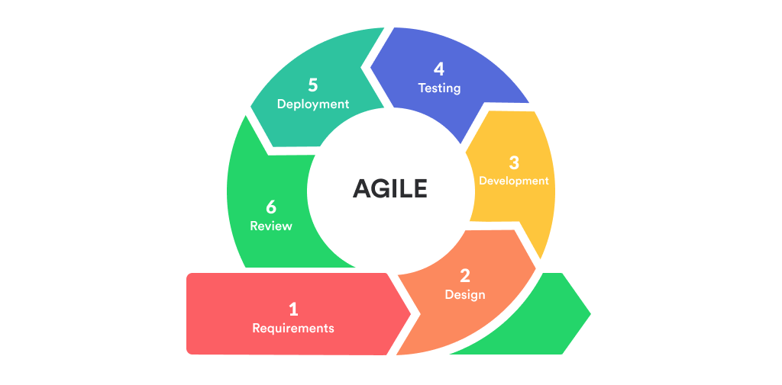
Figure 1: Agile Approach

3.4.1 Architecture Diagram
The system architecture consists of a frontend interface built with frameworks like React or Vue.js, which interacts with the backend using API calls. The backend, developed in technologies like PHP or Node.js, processes business logic, communicates with biometric devices for authentication, and manages data flow between the frontend and database. The database stores user data and biometric records, ensuring secure storage and efficient retrieval of information for the system's operations.

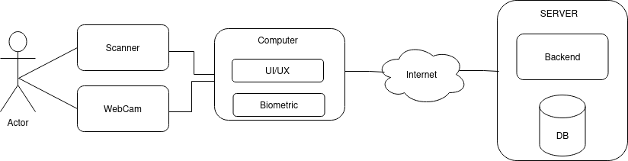

Figure 2: System Design Architecture

This diagram shows how the components are interconnected, including the communication between the frontend, backend, biometric devices, and database.

3.5 Software and Hardware Requirements

3.5.1 Software
- The Frontend will be developed by using Vue.js as a progressive JavaScript framework used for building the user interface (UI) of the system.
- The Backend will also be developed by Laravel Framework which is a PHP framework used for building the backend, handling business logic, and processing requests between the frontend and the database. It supports secure, efficient data handling and management of authentication-related tasks.
- Database will store data (Biometric facts i.e., fingerprints, facial images and recognition) that will be used for user authentication. The database will be implemented using MySQL which is a reliable, open-source relational database that supports high performance and security features necessary for storing sensitive data like biometric templates and user authentication logs.

3.5.2 Hardware
Hardware are components that will accompany the complete implementation of the system. This hardware includes Webcam and Fingerprint Scanner.

3.6 Data Collection and Storage
In the Web-Biometrics for User Authenticity Verification in Zero Trust Access Control project, ensuring that biometric data (such as fingerprints, facial images, and data) is collected, processed, and stored securely is paramount. Below is a detailed explanation of how biometric data will be securely handled throughout its lifecycle:

3.6.1 Biometric Data Collection
Biometric data will be collected using hardware devices such as:
- Fingerprint Scanners for capturing fingerprints.
- Webcam for facial recognition images.
- Microphone for recognition samples.
Each of these devices will collect raw biometric data, which will be temporarily stored in memory during the verification process.

3.7 Implementation Steps
- System configuration (Laravel, Vue.js setup). We will set up the necessary environment for the backend (Laravel) and frontend (Vue.js), ensuring smooth communication between the two layers.
- Registration module for fingerprint, face, and data. We will implement the functionality that allows users to register their biometric data (fingerprints, facial features,) for future authentication.
- Authentication module to verify user identity. Implementation of the authentication system to verify users using their registered biometric data, ensuring only authorized access.
- Session management and user redirection to home page. Implementing session management to handle user login states and ensure secure redirection after authentication.

CHAPTER 4: IMPLEMENTATION PHASE

The implementation phase marks the transition from design to actual system development. In this phase, biometric authentication functionalities such as fingerprint and facial recognition, as well as session handling, are being developed and integrated into the web-based platform.
The following tasks have been completed:
- Environment Setup: Successful configuration of Laravel backend and Vue.js frontend.
- Database Configuration: MySQL database established with user tables and biometric template storage.
- Biometric Devices Integration: Webcam and fingerprint scanner drivers have been integrated with the system using appropriate APIs.
- Registration Module: Users can now register biometric data (fingerprint and face) through the interface.
- Authentication Module: User identity verification using biometrics is implemented.
- Session Management: Secure login sessions are handled using Laravel’s authentication features.

Current Progress
The following functional requirements have been successfully implemented:
- Biometric Data Capture: The system captures biometric data (fingerprint and facial features) directly from hardware sensors (webcam and fingerprint scanner).
- Encrypted Transmission: All biometric data is securely encrypted during transmission from the sensor to the authentication engine using AES encryption.
- User Enrollment: The system allows to enroll users before authentication or processing their biometric inputs.
- User Authentication: The system authenticates users before accepting or processing their biometric inputs.
- Real-Time Data Transmission: The system successfully transmits biometric data from sensors to the authentication engine in real-time.
- Secure transmission of Biometric data: Biometric data are transmitted securely over the system resisting tempering of data.
- Anti-spoofing attack: The system is resistant from spoofing attacks in three methods of attacks which are spoofed photo/image printed, spoofed photo/image in devices and a recorded video for a person attempting the prompted challenges.
- Ant-reply attack: The system is able to resist from reply attack, this can be done by attack by eavesdropping the communication between two or more communicating parties.
- The system also is able to work and withstand against Man in the Middle attack. This ensure whenever an attacker is capable to listen on the communication is unable to extract information or data from the captured traffics.

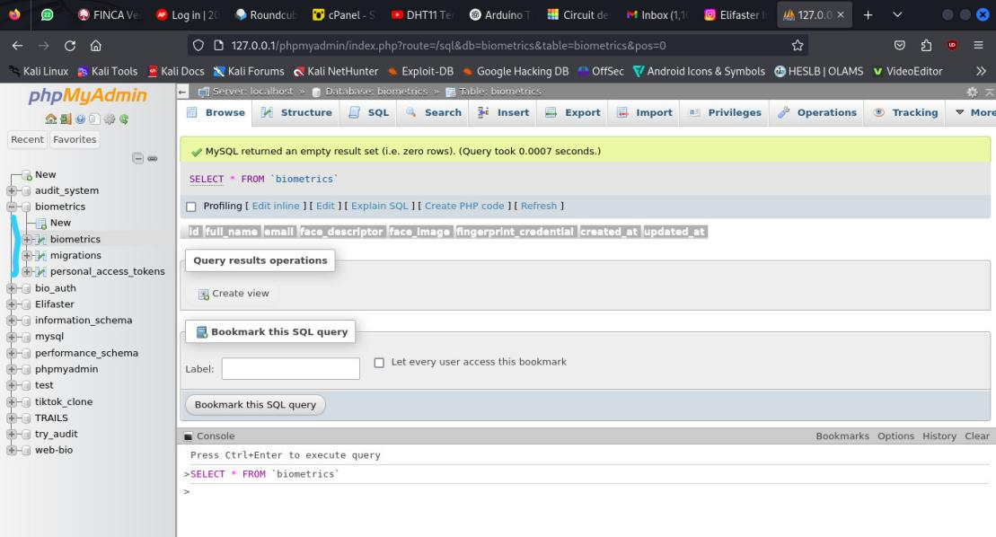
Figure 3: Database Setup

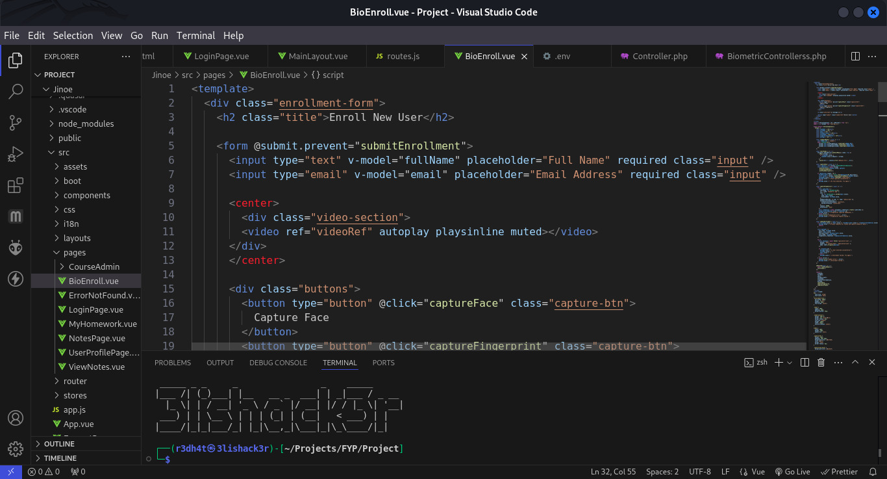
Figure 4: User Enrolment code

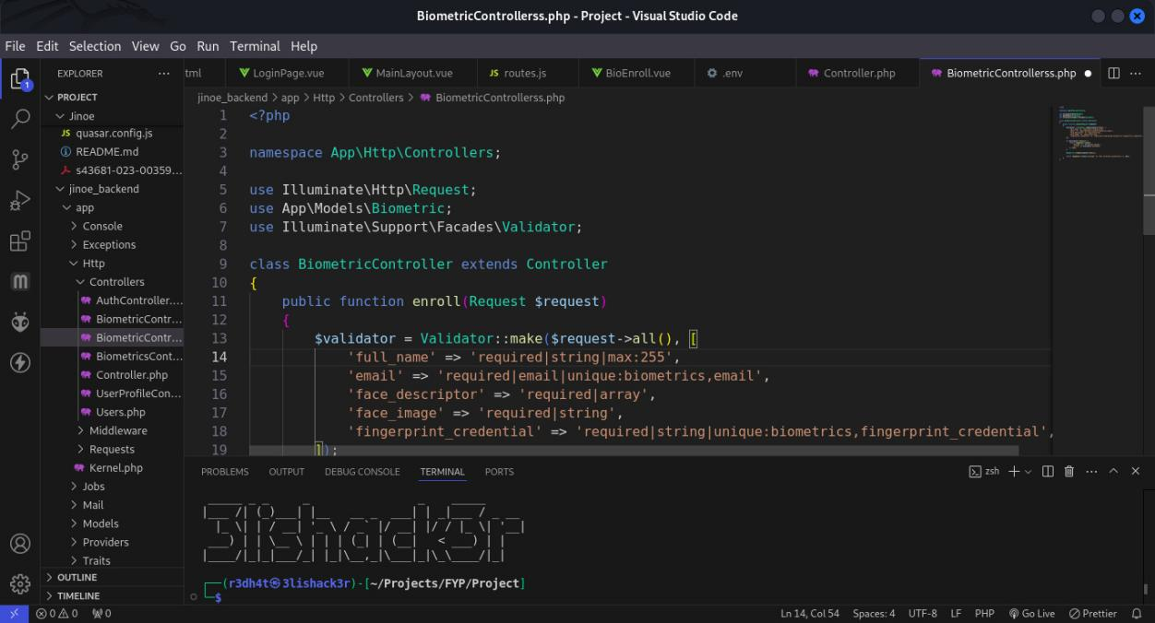
Figure 5: Backend

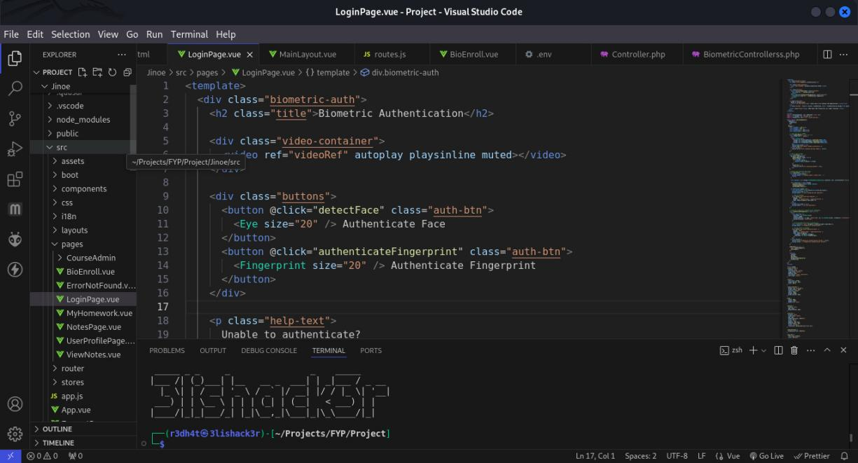
Figure 6: Authentication

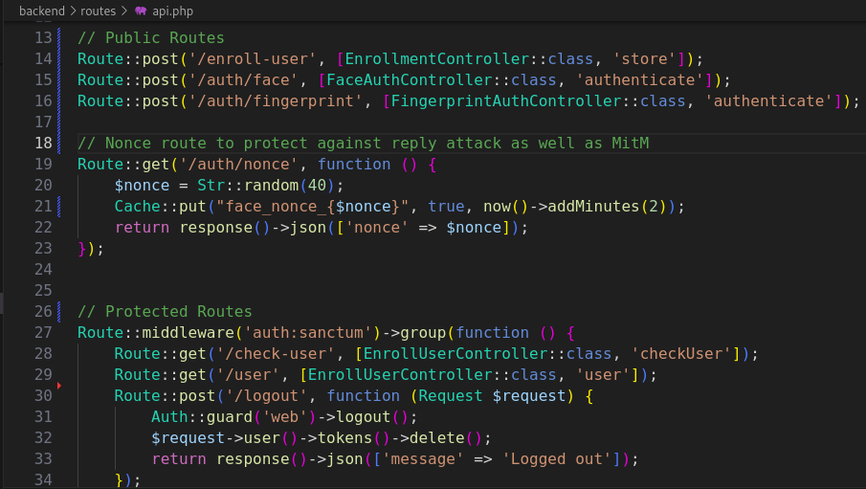
Figure 7: Api for communication between frontend and backend

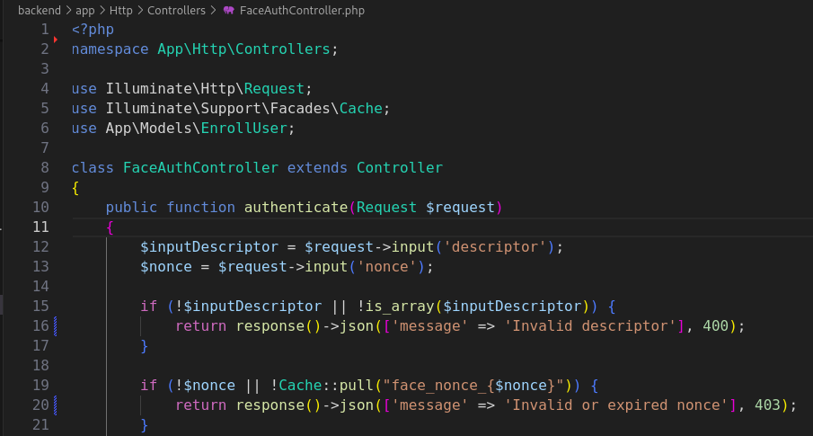
Figure 8: Backend Logic
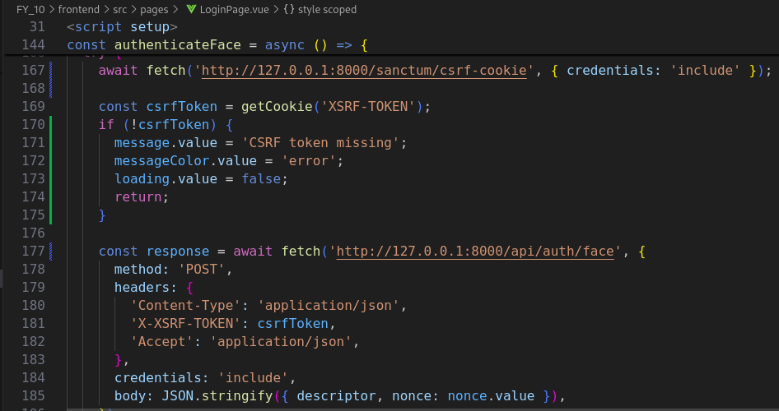
Figure 9: Frontend logic for protecting reply attack
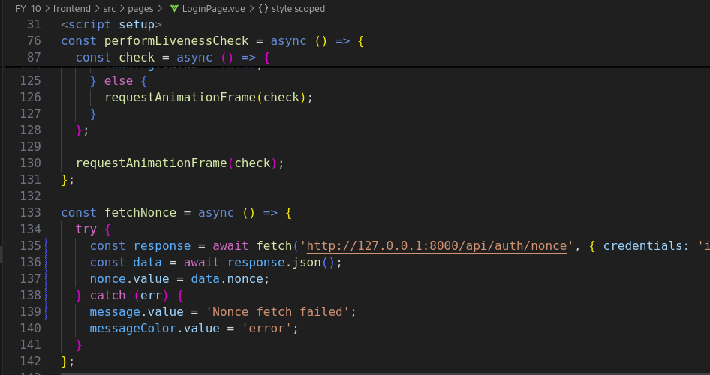
Figure 10: Frontend nonce creation

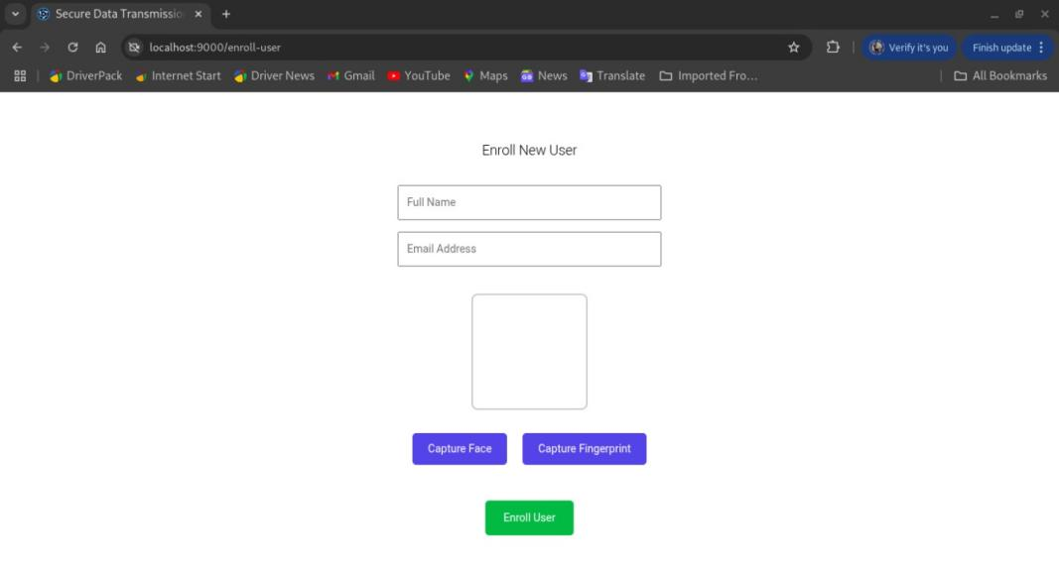
Figure 11: User Enrolment

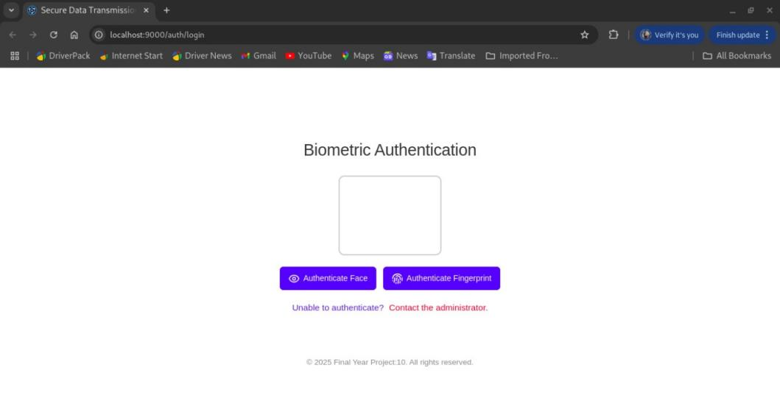
Figure 12: User Authentication

CHAPTER 5: MARKET STRATEGY
The market strategy for the Web-Biometrics for User Authenticity Verification in Zero Trust Access Control project focuses on targeting high-demand industries, outpacing competitors through innovative features, and diversifying revenue streams. By leveraging One-time Licensing, Professional Services, Partnerships and Collaborations, the system ensures long-term sustainability and growth while delivering significant value to customers.

Potential Customers
The system targets a wide range of industries and organizations that prioritize secure access control and user authentication. These include: -
- Government Institutions: To secure access to sensitive government databases, offices, and facilities. Examples: National registries, tax authorities, defense departments, and e-governance portals.
- Financial Institutions: Biometric authentication for customer account access, transaction approvals, and internal employee verification. Examples: Banks, microfinance institutions, and online payment platforms.
- Healthcare Facilities: To secure access to patient records, medical equipment, and staff verification systems. Examples: Hospitals, clinics, and insurance companies.
- Education Sector: Authentication for student and staff access to learning resources, attendance tracking, and exam verification. Examples: Universities, online learning platforms, and training institutions.
- Corporate and Enterprise Sector: Employee authentication for building access, remote work systems, and sensitive data protection. Examples: IT firms, multinational corporations, and startups.
- Smart Infrastructure and IoT Solutions: Integration with smart devices for personalized access control. Examples: Smart homes, smart cities, and IoT-based security systems.

Competitors
The biometric authentication market has several established players and emerging competitors offering similar solutions. However, the proposed system differentiates itself with its Zero Trust Access Control model and emphasis on multi-modal biometrics (fingerprint, face).
- ZKTeco: Focuses on Biometric Identification development, including verification with fingerprints, faces, finger vein patterns, and iris
- KCC: biometric access control systems including fingerprint, palm, iris, and facial recognition, for enhanced building security.
- NEC Corporation: Provides advanced biometric systems for facial and iris recognition.
- Thales: Focuses on secure identity and access management with integrated biometric solutions.

4.3 Revenue Stream
The proposed system will generate revenue through multiple streams to ensure sustainability and profitability. These include: -
- One-time Licensing: A one-time payment for organizations that prefer upfront investment.
- Professional Services: Implementation Services fees for initial setup, system configuration, and user training.
- Partnerships and Collaborations: Collaborating with IT solution providers and hardware manufacturers.

CHAPTER 6: PROJECT TIMELINE AND BUDGET

Project Timeline
The timeline below outlines the major activities and their durations for developing and the implementation of prevention of impersonation using a secure biometric authentication and liveness detection system.
ID | Task name | YEAR (2024/2025)
MONTHS
Activity Duration in (Weeks)
 |  | Nov. |  |  |  | Dec. |  |  |  | Jan. |  |  |  | Feb. |  |  |  | Mar. |  |  |  | Apr |  |  |  | May |  |  |  | June
 |  | W  1 | W  2 | W3 | W  4 | W  1 | W  2 | W  3 | W  4 | W  1 | w2 | W  3 | W  4 | W  1 | W  2 | W  3 | W  4 | W  1 | W  2 | W  3 | W  4 | W  1 | W  2 | W  3 | W  4 | W  1 | W  2 | W  3 | W  4 | W  1 | W  2 | W  3 | W  4
1 | Concept formulation
2 | Concept Note presentation
3 | Proposal writing
4 | Proposal Presentation
5 | Collecting System requirements
6 | System Design and Architecture
7 | System Implementation
8 | Testing
9 | Project progress
10 | Submission of progress report
11 | Writing Final Report
12 | Final Project Presentation
13 | Submission of Report

Table 1: Project Timeline

Project Budget
The table below describe the general budget of items and respectively cost as required to the completion of project.
S/N | ITEM | COST (TSH)
1 | Development cost (Backend and Frontend) | 400,000
2 | Transport Cost
3 | Team travel for meetings | 100,000
4 | Hardware Costs
 | 500GB HDD for data storage | 100,000
 | TOTAL | 600,000

Table 2: The Project Budget

CHAPTER 7: CONCLUSION

Summary
This project introduces a comprehensive multi-biometric authentication system designed to enhance security and efficiency in user verification. By integrating fingerprints, facial recognition, and authentication, the system provides a comprehensive solution that aligns with the principles of Zero Trust Access Control. The proposed approach addresses critical challenges in traditional authentication methods, such as vulnerability to password breaches and single-factor weaknesses, by implementing a multi-modal biometric framework. (Jain, A. K., Ross, A., & Prabhakar, S., 2004).

The system not only ensures higher accuracy in identity verification but also improves user convenience by allowing flexible authentication options. It leverages advanced encryption techniques to securely collect, process, and store biometric data, ensuring compliance with global data protection standards. This project is envisioned as a scalable and cost-effective solution that meets the demands of industries requiring stringent access controls, such as government institutions, financial organizations, healthcare facilities, and enterprises.

The implementation of this system marks a significant step toward a future where secure, efficient, and user-friendly authentication systems are standard in access control solutions. Also, this will help to ensure zero trust access control for critical systems as well as to enhance confidentiality for that particular access.

REFERENCES

Jain, A. K., Ross, A., & Prabhakar, S. (2004). "An Introduction to Biometric Recognition." IEEE Transactions on Circuits and Systems for Video Technology, 14(1), 4-20. This paper provides a comprehensive introduction to biometric recognition technologies, including fingerprints, facial recognition, and authentication.
Kumar, A., & Zhang, D. (2006). "Combining Fingerprint, Palmprint and Hand- Geometry for User Authentication." Proceedings of the 18th International Conference on Pattern Recognition (ICPR). This study examines the fusion of multiple biometric traits to enhance user authentication systems.
Zhang, D., & Wang, Y. (2006). "Combining Fingerprint and Biometrics for Identity Verification: An Experimental Comparison." Proceedings of the 18th International Conference on Pattern Recognition (ICPR). This study explores the integration of fingerprint and biometrics to improve identity verification accuracy.
Al-Hussain, A., & Al-Rassan, I. (2010). A Biometric-Based Authentication System for Web Services Mobile User. King Saud University Journal of Computing, 5(3), 89–95.
Herdanu, W. K., Helmi, R. A. A., & Syamsudin, M. (2023). Integration of Biometrics in Web Applications: Security for Web Apps. International Research Journal of Science, Technology, Education, and Management, 3(2), 103–116.
Karim, N. A., Abdullahi, M. S., & Bello, U. (2024). Online Banking User Authentication Methods: A Systematic Literature Review. Journal of Security Systems, 12.
Kenneth . O, Oliver . O., Clement O. (2016). Multi-biometric Liveness Detection – A New Perspective: West African Journal of Industrial & Academic Resarch.
Sarkar, A., & Singh, B. K. (2020). A review on performance,security and various biometric template protection schemes for biometric authentication systems. Multimedia Tools and Applications.
Simoens, K., Bringer, J., Chabanne, H., & Seys, S. (2012). A Framework for Analyzing Template Security and Privacy in Biometric Authentication Systems. IEEE Transactions on Information Forensics and Security, 7(2), 833– 841.

